UNIX PROGRAMMING WEEK 7 - Introduction to System Programming (continued)
Submitted by : Nisarga Vishwamanjuswamy

- Chapter 3 (sections 3.1 - 3.6), do programming exercise 3.16 on page 106.

Programming exercise 3.16

0 | 0 | 0 | 0
1 | 1 | 1 | 0
1 | 0 | 1 | 0
0 | 0 | 0 | 1
Row 1: 0 fillers
Row 2: Owner Permissions (rwx)
Row 3: Group Permission (r-x)
Row 4: Other Permission (--x)

Example program:
#include <stdio.h>

int main() {
int permissions[4][4] = {
{0, 0, 0, 0},
{1, 1, 1, 0},
{1, 0, 1, 0},
{0, 0, 0, 1}
};

for (int i = 0; i < 4; i++) {
for (int j = 0; j < 4; j++) {
printf("%d ", permissions[i][j]);
}
printf("\n");
}

return 0;
}

OUTPUT:
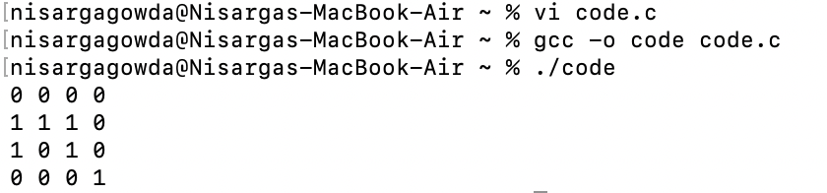

- Chapter 3, do programming exercises 3.11 and 3.17 on pages 105-106.

Programming exercise 3.11
ls.c
#include <stdio.h>
#include <sys/types.h>
#include <dirent.h>
#include <sys/stat.h>
#include <pwd.h>
#include <grp.h>
#include <string.h>
#include <stdlib.h>
#include <time.h>

void do_ls(char []);
void dostat(char *);
void show_file_info(char *, struct stat *);
void mode_to_letters(int, char []);
char *uid_to_name(uid_t);
char *gid_to_name(gid_t);

int main(int argc, char *argv[]) {
if (argc == 1) {
do_ls(".");
} else {
while (--argc) {
printf("%s:\n", *++argv);
do_ls(*argv);
}
}
return 0;
}

void do_ls(char dirname[]) {
DIR *dir_ptr;
struct dirent *direntp;

if ((dir_ptr = opendir(dirname)) == NULL) {
fprintf(stderr, "ls2: cannot open %s\n", dirname);
} else {
while ((direntp = readdir(dir_ptr)) != NULL) {
char path[1024];
snprintf(path, sizeof(path), "%s/%s", dirname, direntp->d_name);
dostat(path);
}
closedir(dir_ptr);
}
}

void dostat(char *filename) {
struct stat info;

if (stat(filename, &info) == -1) {
perror(filename);
} else {
show_file_info(filename, &info);
}
}

void show_file_info(char *filename, struct stat *info_p) {
char modestr[11];
mode_to_letters(info_p->st_mode, modestr);

printf("%s ", modestr);
printf("%4d ", (int)info_p->st_nlink);
printf("%-8s ", uid_to_name(info_p->st_uid));
printf("%-8s ", gid_to_name(info_p->st_gid));
printf("%8ld ", (long)info_p->st_size);
printf("%.12s ", 4 + ctime(&info_p->st_mtime));
printf("%s\n", filename);
}

void mode_to_letters(int mode, char str[]) {
strcpy(str, "----------");

if (S_ISDIR(mode)) str[0] = 'd';
if (S_ISCHR(mode)) str[0] = 'c';
if (S_ISBLK(mode)) str[0] = 'b';

if (mode & S_IRUSR) str[1] = 'r';
if (mode & S_IWUSR) str[2] = 'w';
if (mode & S_IXUSR) str[3] = 'x';

if (mode & S_IRGRP) str[4] = 'r';
if (mode & S_IWGRP) str[5] = 'w';
if (mode & S_IXGRP) str[6] = 'x';

if (mode & S_IROTH) str[7] = 'r';
if (mode & S_IWOTH) str[8] = 'w';
if (mode & S_IXOTH) str[9] = 'x';
}

char *uid_to_name(uid_t uid) {
struct passwd *pw_ptr;
static char numstr[10];

if ((pw_ptr = getpwuid(uid)) == NULL) {
sprintf(numstr, "%d", uid);
return numstr;
} else {
return pw_ptr->pw_name;
}
}

char *gid_to_name(gid_t gid) {
struct group *grp_ptr;
static char numstr[10];

if ((grp_ptr = getgrgid(gid)) == NULL) {
sprintf(numstr, "%d", gid);
return numstr;
} else {
return grp_ptr->gr_name;
}
}

OUTPUT:
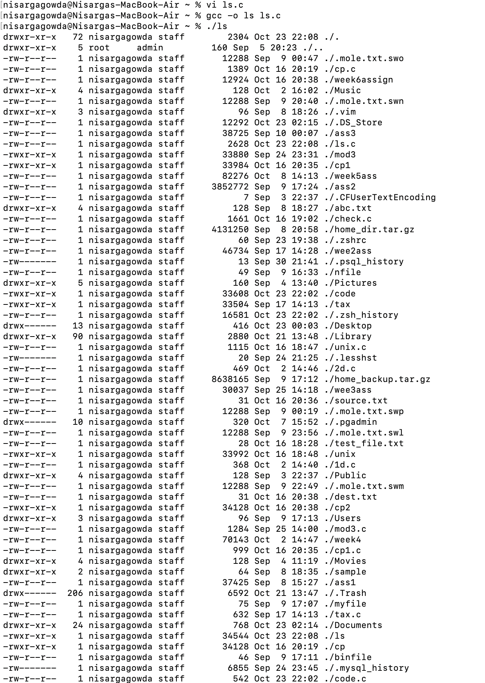
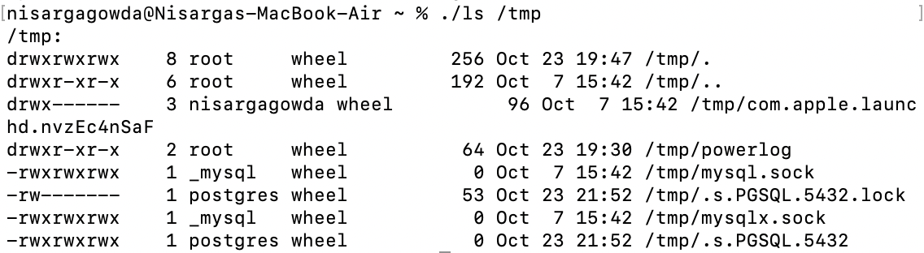

Programming Exercise 3.17
When a process opens a file for reading, it gains an open file descriptor that allows access to the file's contents. If the read permissions for the file are later changed from another terminal, this change affects any new attempts to open the file, but it does not retroactively revoke access for processes that already have an open file descriptor.
Explanation of Read Permissions
- Read Permission: This allows a process to open a file for reading. If you try to open a file without read permissions, you’ll get a Permission Denied error.
- Effect of Changing Permissions: If a process already has an open file descriptor for a file, changing the file’s read permissions from another terminal does not affect the ongoing read operations of the open file descriptor. The file descriptor acts as a ticket for access.
- Result: The process that already has the file open can continue reading it, even if you remove read permissions from the file while the process is sleeping or paused.

Example program:
#include <stdio.h>
#include <unistd.h>
#include <fcntl.h>
#include <stdlib.h>

int main() {
int fd = open("mole.txt", O_RDONLY);
if (fd < 0) {
perror("open");
return 1;
}

char buffer[10];
ssize_t bytesRead;

bytesRead = read(fd, buffer, sizeof(buffer) - 1);
if (bytesRead < 0) {
perror("read");
close(fd);
return 1;
}
buffer[bytesRead] = '\0';
printf("First read: %s\n", buffer);

printf("Sleeping for 20 seconds, remove read permissions from another terminal...\n");
sleep(20);

bytesRead = read(fd, buffer, sizeof(buffer) - 1);
if (bytesRead < 0) {
perror("read");
} else {
buffer[bytesRead] = '\0';
printf("Second read: %s\n", buffer);
}

close(fd);
return 0;
}

First terminal :
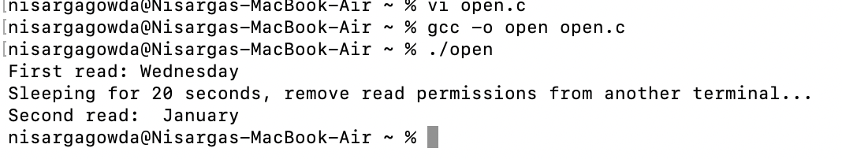

Second terminal

After executing this command, getting permission denied in terminal 1.

- Chapter 4 (sections 4.1 - 4.5), do explorations 4.2 and 4.10 on pages 136-137.

Exploration 4.2

Solution:
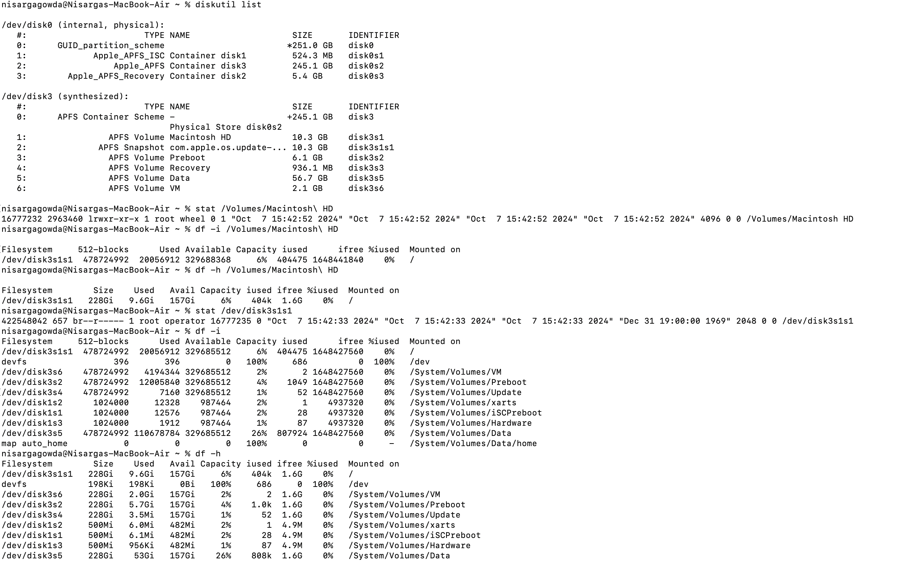

Exploration 4.10

Reasons Why rmdir Doesn’t Delete Non-Empty Directories
- Data Protection: The primary reason is to safeguard against unintentional data loss. If rmdir were allowed to delete a directory containing files or other directories, users might accidentally erase important information without realizing it.
- User Intent: This behavior requires users to explicitly state their intention to remove a directory and all its contents. It encourages a more thoughtful approach to file management, ensuring that users are aware of the consequences of their actions.
- Organizational Structure: Directories often serve to organize files and subdirectories logically. Deleting a directory without removing its contents could disrupt this organization, leading to confusion and making it harder to manage related files.
- Error Prevention: Preventing the deletion of non-empty directories reduces the likelihood of mistakes, especially for those who may not be fully aware of what files are inside a directory. It acts as a safety net, especially in collaborative or multi-user environments.
- Consistency: This design choice also promotes consistency in filesystem operations. Users become accustomed to the idea that they must take additional steps to delete contents within a directory, which leads to more cautious behavior when managing files.

- Chapter 4, do programming exercise 4.16 on page 138.

Programming exercise 4.16

Example program:
#include <stdio.h>
#include <stdlib.h>
#include <unistd.h>
#include <sys/stat.h>
#include <string.h>

void move_file(const char *source, const char *dest) {
struct stat dest_stat;

if (stat(dest, &dest_stat) == 0 && S_ISDIR(dest_stat.st_mode)) {
char new_dest[1024];
snprintf(new_dest, sizeof(new_dest), "%s/%s", dest, source);

if (rename(source, new_dest) == 0) {
printf("Moved '%s' to '%s'\n", source, new_dest);
} else {
perror("Error moving file");
}
} else {
if (rename(source, dest) == 0) {
printf("Renamed '%s' to '%s'\n", source, dest);
} else {
perror("Error renaming file");
}
}
}

int main(int argc, char *argv[]) {
if (argc != 3) {
fprintf(stderr, "Usage: %s <source> <destination>\n", argv[0]);
return 1;
}

const char *source = argv[1];
const char *dest = argv[2];

move_file(source, dest);

return 0;
}

OUTPUT:
